ECE438 Design of Computers
December 2013
Goal: Create a MIPS style 32-bit CPU
The objective of this project was to create a MIPS style 32-bit CPU. Implementing this processor with a simple pipe-line style, inside of the VHDL language.
Creating the CPU would be a hard enough task in and of itself, so the beset course of action I could come up with, was to break the pipe into chunks, with a “main flow” module at the top. This approach helped me keep track of the data flow, and how everything was happening in the pipe. Figure 1A shows the data paths along with a block diagram of the contained modules.
The “second cut at MIPS” file we were given, made almost no sense. I had started building my project with the first cut, and as it turns out they are both the same code, the second cut only being a complete self contained module itself. The first cut was implemented in my project. I chopped it up into two blocks, one for the instruction fetch, the other for the write-back/ out phase. This was done only because it made things easier to follow, that and there was no indication as to how we could or could not implement the given two processes.
Having the modules all split up, the main flow (top module) creates all the necessary signals, instantiates all the sub-modules, creating a two way flow from all the modules to push and pull data from each module.
Results:
My results for this project were at first very disappointing. It was very hard to get the timing just right for everything to happen exactly as intended. After a few trials, and making sure that the text file was not named “mem_init.txt.txt”, the wave forms started to show up.
Over all the results were very good, however the write outs are always off by one clock cycle, as shown below. This could be a result of the first m_data_in being U's, or a stall in the pipe-line, I was unable to figure out the problem in time, other than that, all of the data seems to be correct.
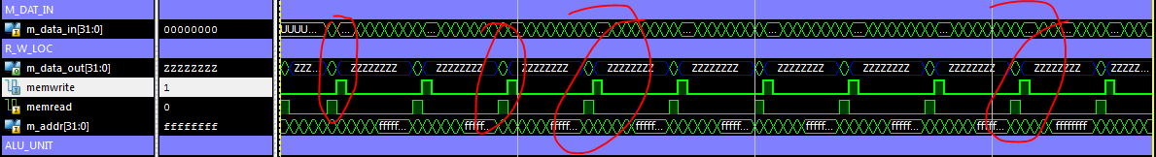
Figure 1B shows wave forms and clock cycles of the first few hundred nano-seconds. The data can be seen changing as well as the write out cycles and all the interacting signals changing on the clock cycles. From this I can see that the pipe-line is working in the correct manner at the very least.
The CPU was implemented only accounting for R and I -type MIPS instructions, so there are no jump addresses being calculated.
The ALU done in project #1 was too slow to use for this project, so for the ALU block of the MIPS, I had to rebuild an ALU, but since there were no constraints on this ALU, it was made in the most efficient way I could think of in order to get the correct information out of it.

Final Thoughts:
This was one of the more difficult projects I have undertaken. The main issue was thinking ahead of how I was going to implement all of the features and how to get all the modules to talk to each other and pass correct data back and forth. I had to go through a few revisions and designs before I was able to settle on the one that I had chose. Thankfully, this seems to be a very popular graduate project a lot of people have done, and were able to give me pointers and things to avoid doing, such as creating the registers in the main-flow module.
At first it was behaving differently than I had thought at first, but then I had realized that there needs to be some way to stall the pipe-line from the main-flow, once I figured out how to do this, it started to look more like a CPU.
Overall, it was a very insightful project, and will be interesting expanding on it to make it behave like a system-on-a-chip.

